1.Socratic prompting Method:
I want to build a scalable, data-driven Selenium automation framework.

Do not provide the implementation immediately. Instead, act as a Solution Architect and gather my requirements using the Socratic questioning technique.

Rules:

* Ask exactly one question at a time.
* Each question should provide multiple-choice options (A, B, C, D...) along with a brief explanation of each option.
* Wait for my response before asking the next question.
* Ask only the questions necessary to fully understand my requirements.
* Do not make assumptions unless I explicitly ask for recommendations.

Once all the requirements are gathered:

1. Summarize my chosen requirements.
2. Explain the architecture and design decisions.
3. Provide the recommended project structure.
4. Implement the complete framework step by step with well-commented Java code.
5. Explain why each design choice was made and discuss possible alternatives.
6. Follow industry best practices for Selenium, TestNG, Maven, Page Object Model, and data-driven testing.

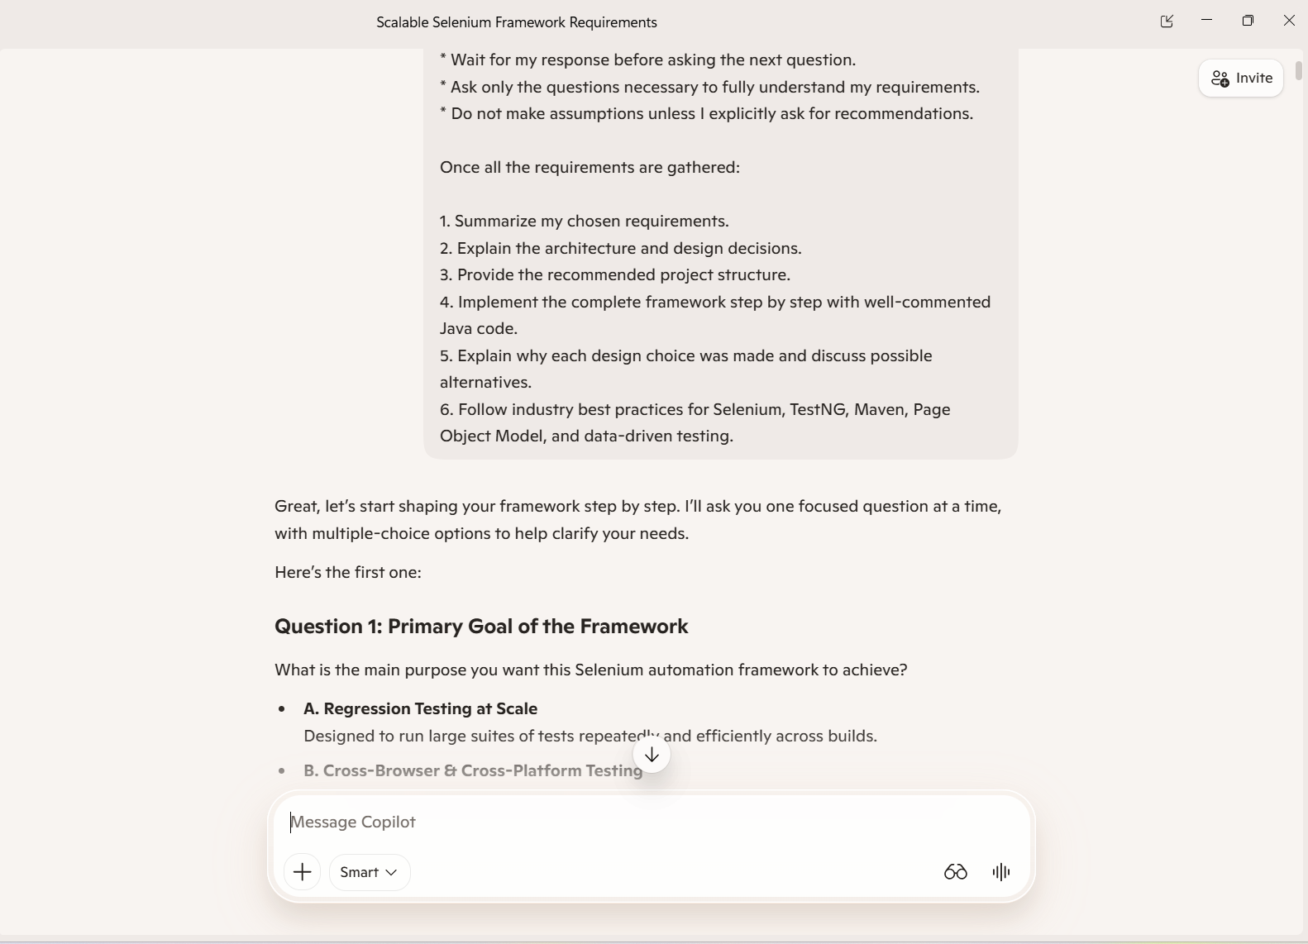

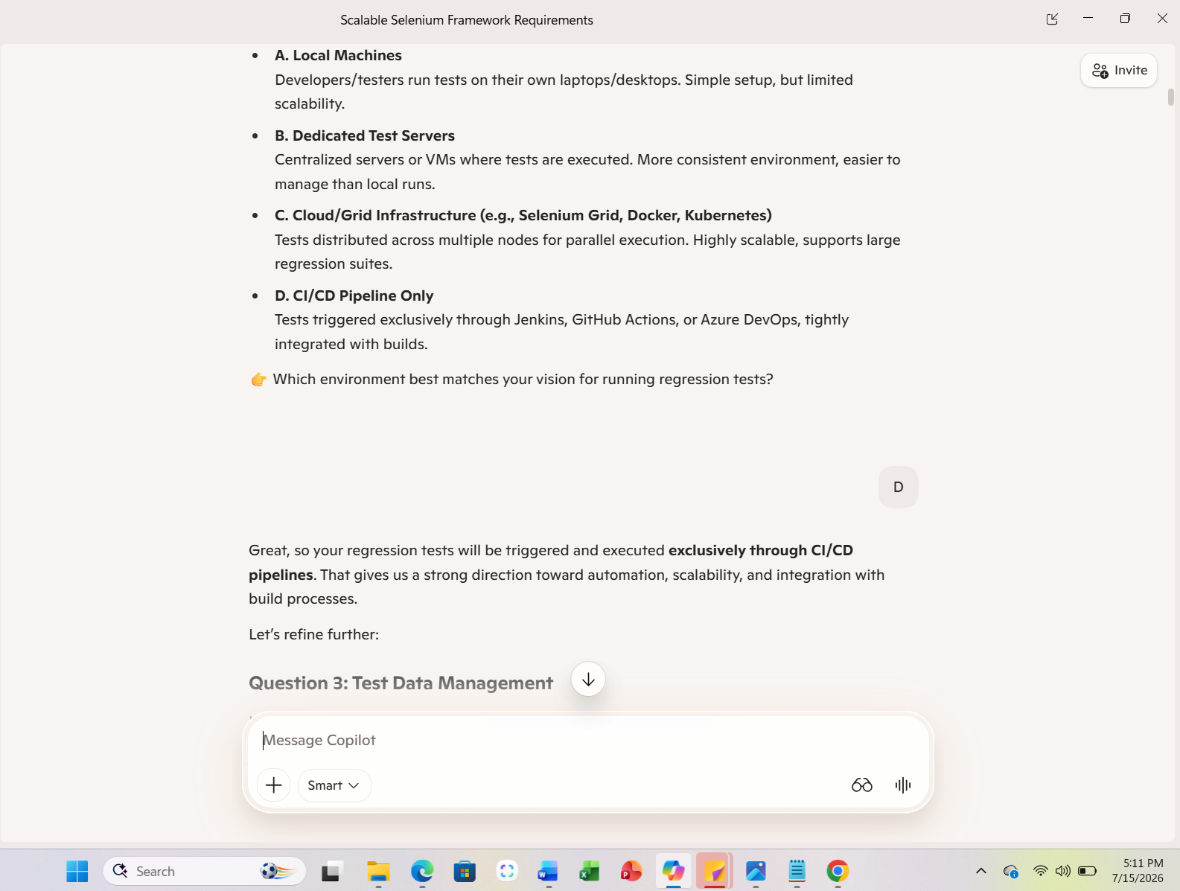

After answering all the questions, the below is the outcome:
Recap: draft version
Finalized Requirements Recap
- Primary Goal: Regression testing at scale
- Execution Environment: CI/CD pipeline (GitLab CI/CD)
- Test Data Management: External files (Excel, CSV, JSON, XML)
- Test Design Pattern: Hybrid (POM + Data-Driven + Utilities)
- Execution Strategy: Parallel execution
- Reporting: Extent/Allure Reports
- Build Tool: Maven
🔧 Architecture & Design Decisions
- Core Framework Layering
  - Test Layer (TestNG): Defines regression suites, parallel execution, and CI/CD triggers.
  - Page Object Layer: Encapsulates UI elements and actions for maintainability.
  - Data Layer: Reads test data from external files (Excel/CSV/JSON).
  - Utility Layer: Provides reusable helpers (logging, waits, screenshots).
  - Reporting Layer: Integrates Extent/Allure for rich reports.
- Scalability
  - Parallel execution configured via TestNG XML and GitLab runners.
  - Data-driven tests ensure minimal duplication of logic.
- CI/CD Integration
  - GitLab pipeline triggers regression suites automatically.
  - Artifacts: Reports and logs uploaded after each run.
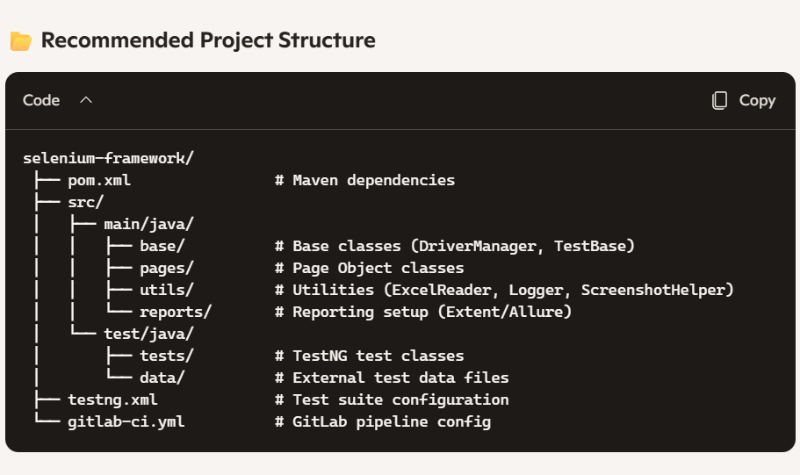

Key Files
- pom.xml → Maven dependencies (Selenium, TestNG, Extent, Allure, Apache POI, Logging).
- DriverManager.java → ThreadLocal WebDriver for parallel execution.
- TestBase.java → Setup/teardown hooks for TestNG.
- LoginPage.java / HomePage.java → Page Object classes.
- ExcelReader.java → Reads test data from Excel.
- LoggerUtil.java → Centralized logging.
- ScreenshotHelper.java → Captures screenshots on failure.
- ExtentManager.java / ExtentTestListener.java → Reporting integration.
- LoginTest.java → Sample regression test with data-driven execution.
- testng.xml → Defines parallel execution and browser parameter.
- .gitlab-ci.yml → GitLab pipeline config for parallel test execution and report artifacts.

Final Version for 📘 Selenium Regression Framework – Design & Implementation Document
1. Project Overview
A scalable, data-driven Selenium automation framework designed for regression testing at scale, integrated with GitLab CI/CD.
Key Features
- CI/CD pipeline execution only (GitLab).
- Hybrid design pattern (POM + Data-Driven + Utilities).
- Parallel execution with ThreadLocal WebDriver.
- External test data (Excel/CSV/JSON/XML).
- Rich reporting (Extent + Allure).
- Maven for build and dependency management.
2. Architecture
Layers
- Base Layer → WebDriver setup/teardown (parallel execution).
- Page Object Layer → Encapsulates UI elements and actions.
- Utility Layer → Excel data handling, logging, screenshots.
- Reporting Layer → Extent + Allure integration.
- Test Layer → TestNG test classes with data-driven execution.
- CI/CD Layer → GitLab pipeline configuration.
3. Project Structure
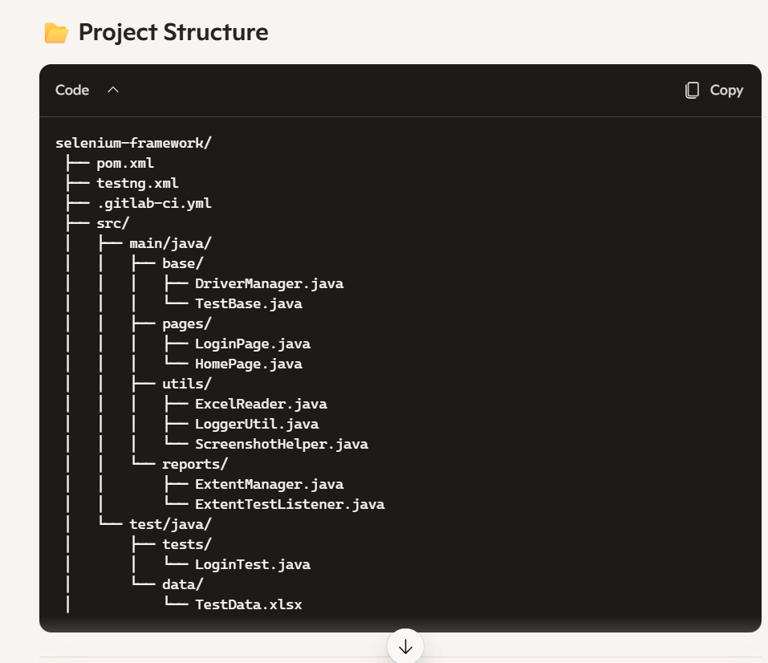

4. Implementation Highlights
Base Layer
- DriverManager.java → ThreadLocal WebDriver for parallel execution.
- TestBase.java → Setup/teardown hooks with browser parameterization.
Page Object Layer
- LoginPage.java → Encapsulates login actions.
- HomePage.java → Represents post-login landing page.
Utility Layer
- ExcelReader.java → Reads test data from Excel (Apache POI).
- LoggerUtil.java → Centralized logging (SLF4J + Logback).
- ScreenshotHelper.java → Captures screenshots on failure.
Reporting Layer
- ExtentManager.java → Configures Extent Reports.
- ExtentTestListener.java → Hooks into TestNG lifecycle, attaches screenshots.
- Allure Annotations → Step-level reporting.
Test Layer
- LoginTest.java → Data-driven test using Excel + Page Objects.
- testng.xml → Defines parallel execution and browser parameter.
CI/CD Layer
- .gitlab-ci.yml → GitLab pipeline with parallel execution, artifacts, and Allure report generation.
5. Execution Flow
- Pipeline Triggered → GitLab CI/CD starts regression job.
- Maven Build → Dependencies resolved, tests compiled.
- TestNG Execution → Parallel tests run using ThreadLocal WebDriver.
- Data-Driven Tests → ExcelReader feeds multiple datasets.
- Reporting → Extent + Allure generate interactive reports with screenshots.
- Artifacts Stored → Reports and screenshots uploaded to GitLab artifacts.
6. Alternatives & Extensions
- WebDriverManager → Auto-download drivers.
- Dockerized Selenium Grid → Distributed execution.
- Database-driven test data → For dynamic enterprise scenarios.
- Allure-only reporting → Sleeker UI, less setup.
7. Conclusion
This framework provides a robust, scalable, and CI/CD-ready solution for regression testing. It balances maintainability (POM), flexibility (data-driven), speed (parallel execution), and visibility (rich reporting).

